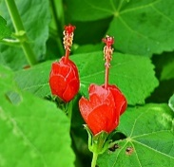  Turk's Cap Malvaviscus arboreus var. drummondii Native deciduous shrub. 2-3’ high. Blooms red May-Nov. Sun to pt. shade, dry-moist, well-drained, neutral soil. Best in part shade, drought tolerant. Loved by hummingbirds. Moderately deer resistant. Germinates in 3 weeks at 70º from fresh, untreated seeds planted outside after the danger of frost is past or start inside. Cover the seeds 1/4 - 1/2 inches. Harvested 20____ | 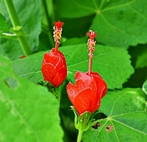  Turk's Cap Malvaviscus arboreus var. drummondii Native deciduous shrub. 2-3’ high. Blooms red May-Nov. Sun to pt. shade, dry-moist, well-drained, neutral soil. Best in part shade, drought tolerant. Loved by hummingbirds. Moderately deer resistant. Germinates in 3 weeks at 70º from fresh, untreated seeds planted outside after the danger of frost is past or start inside. Cover the seeds 1/4 - 1/2 inches. Harvested 20____ | Turk's Cap Malvaviscus arboreus var. drummondii Native deciduous shrub. 2-3’ high. Blooms red May-Nov. Sun to pt. shade, dry-moist, well-drained, neutral soil. Best in part shade, drought tolerant. Loved by hummingbirds. Moderately deer resistant. Germinates in 3 weeks at 70º from fresh, untreated seeds planted outside after the danger of frost is past or start inside. Cover the seeds 1/4 - 1/2 inches. Harvested 20____

