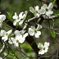
Flowering Dogwood Cornus florida
Deciduous native understory tree, Keystone Species, 25’t x 15’w. Pt. shade, moist, well-drained, blooms April, Sow 5 to 6 inches apart in rows or in deep cells. Or seeds can be cold stratified for 3-4 mo. then put outside at 70º germinates in 2 weeks. Host to Spring Azure butterfly, Not deer resistant. Protect saplings from buck rub. Seeds are viable for 3 years if refrigerated. Collected 20____
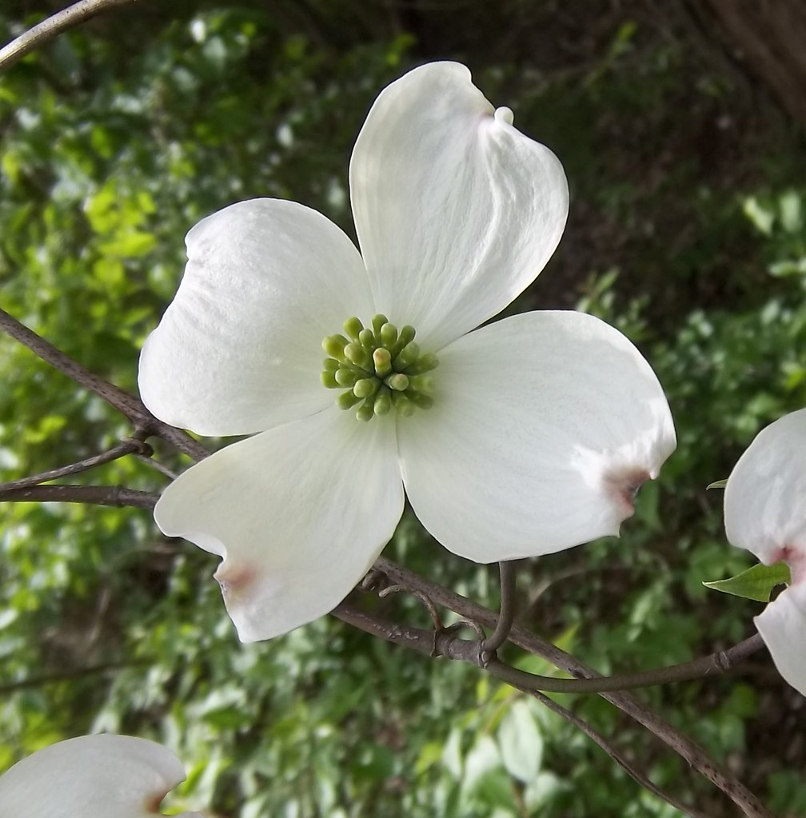
This Photo by Unknown Author is licensed under CC BY-NC-ND
This Photo by Unknown Author is licensed under CC BY

